After spraying the basecoat, your graphics or flame job is sprayed, normally leaving a hard edge. This is the first 4 layers of the paint job,
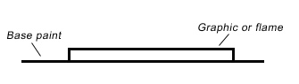
When clearing over the graphics or flame job, the clear coat follows the contour of the surface, thus still leaving an edge, however it is much softer after its been polished. This is usually about the 8th layer of paint on the bike.
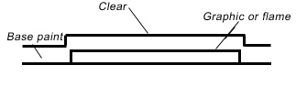
For our premium paint jobs, we bypass the wetsanding, and will machine sand the surface down to a flat finish. Then another 3 to 4 coats of clear coating is sprayed on thus making the total coats of paint to 12 layers. The surface is then wetsanded, buffed and polished, giving you the ultimate paint job. The extra coating will give extra protection and depth and also the surface of your bike will be as smooth as ice.

